Activity 1

1.done, faster memory, yes we need it

2.done

3.you need an offset/combination of index and offset and use tag

4. 32, no

5. 6 bits, log2(n)

6. n*b, rows * num_bytes

7.

8. a. 2^20

b. log2(8) = 3

c. 16

d. index bits shows you the rows/each row represents a block/direct-mapped cache only/4 bits

e. 20-4-3=13 bits

f. 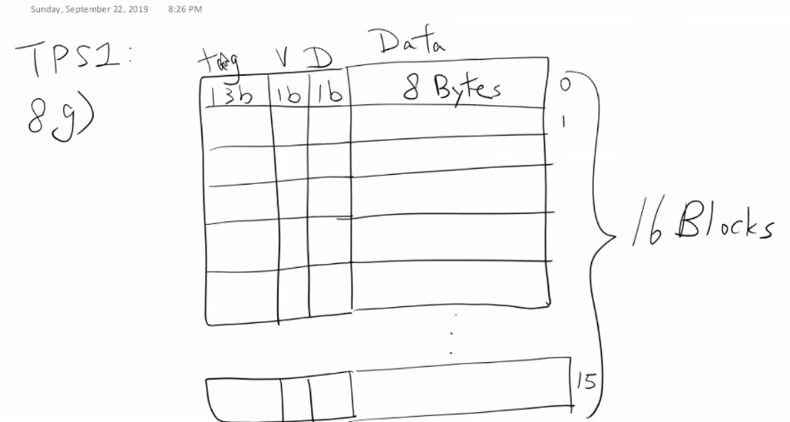

drawing that was shown

g. tag = 13

v = 1

d = 1

block_bits = 8bytes = 8*8-64

64 + 13 + 1 + 1 = 79 bits

Activity 2

1. Block maps to a fixed location in the cache. Trashing(two blocks map to the same location) can happen. Two addresses that map to the same set causes issues.
2. Okay
3. A. 2^20 = 1048576 bytes

b. 3

c. 16

d. 8 sets

e. 3

f. offset = 3 bits index = 3 bits address = 20 bits tag = 20 – 3 – 3 = 14 bits

g. same as above but v and d go into the memory

h. 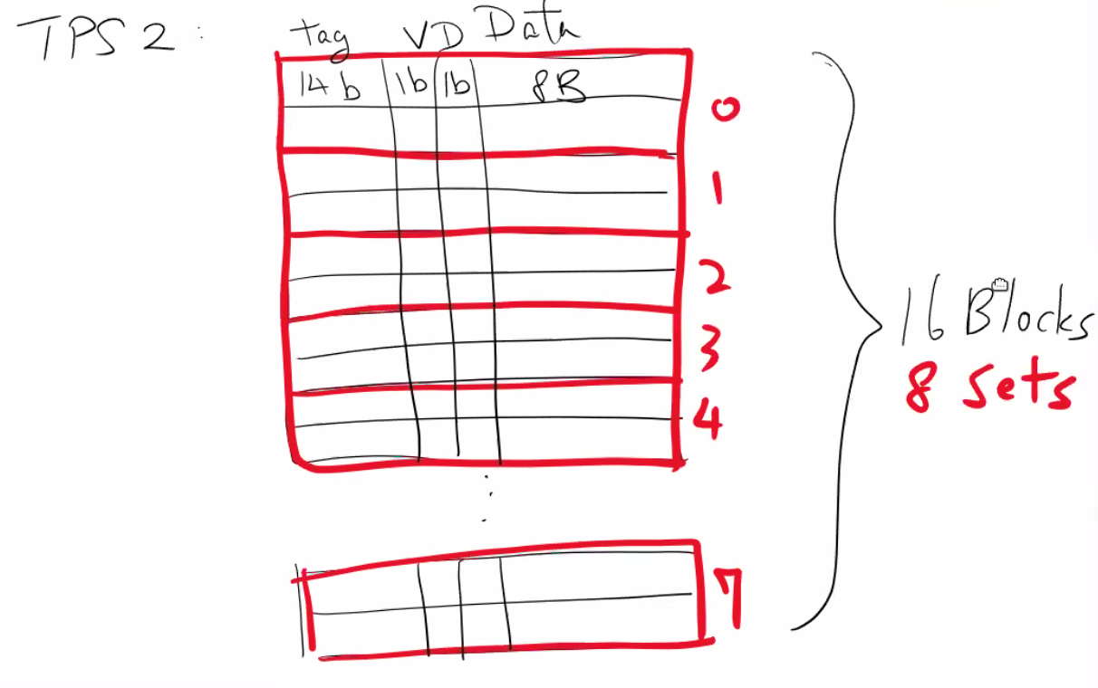

image that was shown

80 bits